The grocery tracking program I have made is designed specifically with the user in mind. There are four options for the user to choose from. The first three options perform actions, while the fourth option simply exits the program. The program starts with the title of the program, followed by a menu of options to choose from. This menu is presented to the user after every action is carried out.

Fit also into this program is user input validation, so that there is zero chance of the user making a mistake that leads to a program crash. If the user inputs an incorrect character when choosing from the menu options (during menu selection, the user is only permitted to enter 1, 2, 3, or 4), an error message will pop up and the user will be presented with the menu again and repromoted for correct input:

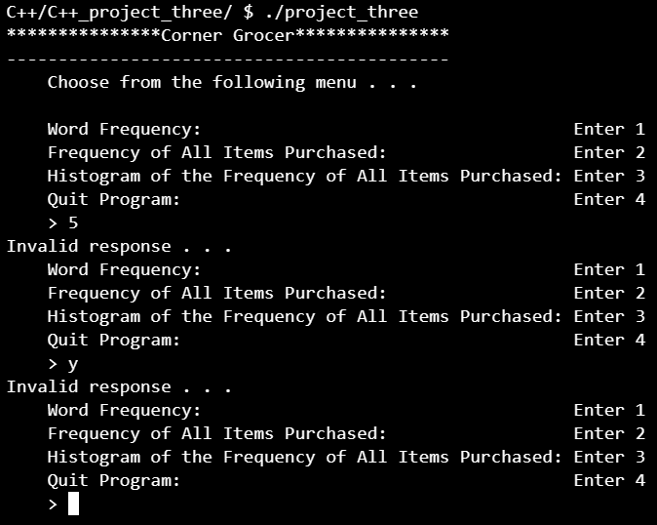

If the user enters 1, they will be prompted to enter a word, in which the program will then search the input.txt file for that word and return to the user the number of times that word is repeated in the file. Note that capitalization is important here:

If 2 is entered, the program will return to the user a list of each item in the file with the frequency of times the item is repeated within the file:

If the user enters 3, a similar chart is displayed, only it is in the form of a histogram - the frequency of each object represented by asterisks (\*):

Lastly, if 4 is entered, the program gracefully exits. Note that I added timers in the code to pause for two seconds between line prints when the program is exiting to give the user a more “cinematic” experience to the exiting of the program:

